Global Health Insights: How Air Quality and Diet Shape Disease Rates

1. Project Description
Introduction and Project Motivation
Air quality and dietary habits are two critical determinants of public health, each linked to widespread disease burden. Air pollution alone is responsible for roughly 7 million premature deaths per year worldwide, as it contributes to respiratory illnesses, heart disease, stroke, and other conditions. Likewise, unhealthy diets are a major risk factor for chronic diseases – including cardiovascular disease, cancer, and diabetes – and drive a significant share of global morbidity and mortality. Despite being often studied in isolation, these environmental and lifestyle factors may interact in ways that jointly influence health outcomes. Emerging research suggests, for example, that adherence to healthy dietary patterns (such as a Mediterranean diet) can mitigate some health risks associated with long-term air pollution exposure. This graduation-level project is motivated by the need to explore how the combined effects of air quality and diet relate to disease prevalence on a global scale. By focusing on exploratory data analysis (EDA) and visualization rather than predictive modeling, the project aims to uncover patterns and insights that can deepen our understanding of multifactorial health challenges. Initially, the project focused on exploratory data analysis (EDA) and dashboard creation using Power BI. However, the project was later extended through the integration of a predictive modeling component to provide deeper analytical value. This enhancement allows users to examine how different nutritional inputs may influence health recovery outcomes.

- Purpose: The primary goal of Global Health Insights is to analyze global data sets and investigate correlations between air pollution levels, dietary patterns, and disease rates across different regions. The project will conduct a comprehensive EDA using tools like Excel, SQL, and Power BI to identify trends, anomalies, and relationships in the data. Through this analysis, the team seeks to answer questions such as: Do countries with higher air pollution and poor diet quality experience elevated rates of certain diseases? Could improved diet potentially offset some ill effects of polluted environments? The ultimate purpose is to generate evidence-based insights that bridge environmental health and nutrition, informing both the academic community and public health stakeholders. Demonstrate the value of integrating predictive analytics into global health studies.
This combined analytical and predictive approach offers a comprehensive perspective—bridging environment, lifestyle, and health outcomes.

2. Societal Relevance and Significance
Understanding the intertwined impact of air quality and diet on disease prevalence carries substantial societal importance. Modern health problems, especially non-communicable diseases (NCDs) like heart disease, chronic respiratory illness, and diabetes, often result from a confluence of risk factors. The World Health Organization recognizes unhealthy diets and air pollution as significant drivers of NCD mortality. This implies that populations facing both poor air conditions and suboptimal diets are particularly vulnerable. By analyzing these factors together , leveraging AI prediction models and the project addresses a holistic public health question: how do environmental and nutritional determinants collectively shape health outcomes in societies?
From a policy perspective, insights from this project can guide more integrated interventions. Governments and health organizations typically develop initiatives to improve air quality (e.g. emissions controls) and to promote healthy eating (e.g. dietary guidelines) separately. However, a combined understanding is crucial for targeting resources effectively. For instance, if the analysis finds that regions with high particulate pollution and high consumption of unhealthy foods see disproportionally high rates of cardiovascular or respiratory diseases, this could justify coordinated policies – such as coupling air pollution reduction with nutrition programs – to achieve compounded health benefits. Moreover, many low- and middle-income communities suffer the dual burden of polluted environments and limited access to healthy foods; shedding light on this reality has equity implications. It can raise awareness that improving living conditions (clean air) and lifestyle (diet) concurrently is essential to reducing health disparities. In summary, the project’s focus on the combined effects of air pollution and diet is socially relevant because it aligns with global health priorities to combat NCDs through comprehensive, multi-sectoral approaches. By disseminating findings in an accessible visual format, the project will also engage the public and policymakers, potentially influencing community health initiatives and fostering informed decision-making.

3. Methodology and Workflow
The project will be executed in structured phases, each leveraging specific tools (Excel, SQL, Power BI) for designated tasks. The workflow is entirely centered on exploratory analysis and visualization of data – with machine learning model . The student team’s process is outlined below:
1. Data Collection and Sources
In the initial phase, the team will gather relevant datasets from credible international sources. Likely data inputs include:
- Air Quality Data: Measurements of ambient air pollution (e.g. annual average PM2.5 concentrations, air quality index values, levels of pollutants like NO₂) for countries or cities worldwide, obtainable from organizations such as WHO (e.g. the Global Health Observatory air pollution database) or environmental agencies.
- Dietary Patterns Data: Statistics reflecting dietary habits or nutritional intake by country/region. This may involve data on per capita consumption of food groups, prevalence of dietary risk factors (like low fruit/vegetable intake or high sugar/salt intake), or diet quality indices from sources like the FAO, WHO, or global nutrition surveys.
- Disease Rates Data: Health indicators capturing disease burden, such as prevalence or incidence rates of major NCDs (for example, ischemic heart disease, stroke, lung cancer, chronic respiratory diseases, diabetes) in each country. These could be drawn from WHO reports, the Global Burden of Disease study, or World Bank health datasets.
The team will use Excel as an initial platform to compile and examine these datasets. Many sources provide data in CSV or Excel format, which can be readily opened and combined in Excel. The team will load each dataset into Excel to perform a preliminary review of its contents (checking column structures, sample values, and any obvious issues). SQL will also be utilized at this stage if the data volumes are large or if multiple datasets need to be integrated systematically. For example, the team might import the raw data files into a SQL database (such as MySQL or SQL Server) to facilitate efficient querying and merging. Using SQL from the outset provides a robust way to handle large tables (e.g. pollution readings for hundreds of cities over many years) and to ensure data integrity when linking disparate sources. Throughout the data collection phase, emphasis will be placed on recording metadata (data source, year, definitions) in a project log for transparency and academic rigor.
2. Data Cleaning and Integration
Once the data is collected, the team will perform thorough cleaning and integration to prepare for analysis. Data cleaning involves identifying and correcting errors or inconsistencies in the data. Using Excel, team members can sort and filter records to spot anomalies (such as impossible values, duplicate entries, or missing fields). For instance, if a country’s diet dataset uses country names that don’t exactly match those in the disease dataset, Excel will help in finding and standardizing those labels (through functions or manual editing). Excel’s intuitive interface is well-suited for spot-checking data quality – the team can use it to fill in or remove missing values, convert units (e.g. ensuring all air pollution metrics are in the same units), and perform quick transformations (like computing per-100,000 population disease rates if needed).
In parallel, SQL will be instrumental for integrating the datasets. The team will design a relational schema to house the different data tables – for example, one table for air quality metrics by location and year, another for diet metrics by location and year, and another for disease rates. Using SQL join operations, these tables can be merged on common keys (such as country codes and year) to create a unified analytical dataset. The team will write SQL queries to accomplish tasks like:
- Merging air pollution data with disease data to align each health outcome with corresponding pollution exposure.
- Adding dietary data into this merged set, so that for each country-year (or relevant unit) there is a combined record of air quality, diet indicators, and disease outcomes.
- Performing data validation checks with SQL (for example, ensuring that all countries in one dataset are represented in the others, or calculating basic summary statistics to spot outliers).
By using SQL’s aggregation functions, the team can also compute new fields if necessary (such as an average diet score or pollution index over a multi-year period, to smooth fluctuations).
Throughout cleaning and integration, version control and documentation will be maintained. Each transformation (whether done via Excel or SQL) will be documented to ensure reproducibility. By the end of this phase, the team will have a clean, integrated dataset ready for exploration, with Excel and SQL having jointly facilitated a reliable data preprocessing pipeline.
3. Exploratory Data Analysis (EDA)
With a polished dataset in hand, the team will conduct extensive exploratory data analysis to uncover patterns and relationships. EDA is a visual and statistical investigation of the data’s characteristics, done without preconceptions, to let the data “speak for itself.” In this project, EDA will span multiple tools and techniques:
- Descriptive Statistics: The team will calculate summary statistics (using Excel or SQL queries) to understand distributions of key variables. For example, they will determine the range and average of air pollution levels globally, identify which regions have the highest vs. lowest diet quality measures, and examine the mean incidence of diseases of interest. Excel’s built-in functions (AVERAGE, MEDIAN, STDEV, etc.) and PivotTables will allow quick computation of these summaries. In parallel, SQL can generate aggregated views (e.g. average disease rate by continent or quartiles of pollution exposure) to reveal high-level trends.
- Correlation Analysis: A core part of the EDA will be exploring correlations and associations between variables. The team will look at relationships such as air pollution vs. disease rates, diet quality vs. disease rates, and the combined relationship of air pollution and diet together with health outcomes. Excel can be used to compute correlation coefficients or create scatter plots for initial insight – for instance, plotting country-level PM2.5 concentration against life expectancy or heart disease prevalence to see if a trend is evident. For more complex querying, SQL can be used (for example, selecting subsets of data like “countries with above-average pollution and poor diet” and comparing their health statistics against others).
- Initial Visual Exploration: Even before formal visualization in Power BI, the team may use Excel’s chart tools to create preliminary graphs. Simple bar charts, scatter plots, or line graphs (for time trends if temporal data is available) will help identify notable patterns that merit deeper investigation. For example, a time-series line chart could show how a country’s pollution levels and disease rates moved over the same period, or a clustered bar chart could compare disease rates in groups of countries stratified by diet quality.
Crucially, Power BI will also play a role in EDA due to its powerful interactive features. The team can import the cleaned data into Power BI and use its drag-and-drop interface to quickly slice the data in different ways. By applying filters or creating quick visuals, they can dynamically explore questions (e.g. “How does the relationship between diet and disease look in Asia versus Europe?” or “Do outlier countries exist where high pollution does not coincide with high disease rates?”). This interactive exploration enables the team to spot patterns that static analysis might miss. For instance, Power BI could generate a scatter plot of pollution vs. disease with points colored by diet quality category – allowing the team to visually assess if countries with healthier diets fall below the trend line (indicating possible protective effects).
Throughout the EDA phase, the students will iteratively refine their focus, noting which findings are most compelling or surprising. All analysis steps are purely exploratory and descriptive; no machine learning algorithms will be applied, in keeping with the project scope. By the end of this phase, the team will have a set of key observations and hypotheses (for example, “regions with high particulate pollution and low fruit/vegetable intake have markedly higher rates of chronic respiratory illness”) that will shape the narrative of their results.
4. Data Visualization and Dashboard Development
After uncovering the salient patterns in the data, the team will translate these findings into clear and insightful visualizations. This phase leverages Power BI as the primary visualization tool to create an interactive dashboard titled "Global Health Insights". The dashboard will be designed to allow users – whether professors, public health officials, or the general public – to explore the data and findings intuitively.
Key elements of the dashboard and visualization process include:
- Multiple Visualization Types: The team will create a variety of chart types to convey different aspects of the analysis. For instance, a global map visualization will illustrate geographic variations in air quality and disease rates (using color gradients to show pollution levels and markers or tooltips to display disease statistics for each region). Time-series line charts might be included if the data has a temporal component, showing trends in pollution or diet metrics alongside trends in disease incidence. Bar charts or column charts can compare groups of countries (such as comparing disease rates in groups with the worst air quality vs. the best air quality). A scatter plot with interactive filtering could be a centerpiece – e.g. plotting each country’s air pollution level against a particular disease rate, with the ability to highlight countries by region or by diet category.
- Interactivity: One of the strengths of Power BI is the ease of adding interactive filters and slicers. The dashboard will enable users to filter the view by parameters such as region (continent or country selection), year (if applicable), or specific diseases. For example, a user could select “Respiratory diseases” from a dropdown and see all visuals update to focus on respiratory illness rates in relation to diet and air quality. They could then switch to “Cardiovascular diseases” and observe any differences. The team will configure these interactions so that policymakers or academics can ask their own questions of the data in real-time. This interactivity not only makes the findings more engaging but also allows for validation of insights across different subsets of data.
- Use of Excel and SQL in Visualization Prep: While Power BI is the main tool for the final dashboard, the team will leverage Excel in designing visual elements (for example, using it to create mock-up charts or calculate specific indices that feed into visuals). They might also use SQL queries to prepare summary tables or calculated fields that are then imported into Power BI (for instance, creating a table of “combined risk scores” or categorizing countries into tertiles of pollution and diet for easier visualization). These preparatory steps ensure that the Power BI visuals are backed by correctly computed data points.
- Design Principles: The dashboard will be developed with formal academic presentation standards in mind. This means careful attention to clarity and labeling – all charts will have appropriate titles, axis labels (with units), and legends. The team will also include narrative text boxes or tooltips within the dashboard explaining key insights, so that a viewer can understand the takeaways without ambiguity. The color schemes and layout will be chosen to be visually appealing yet professional, ensuring that the content is accessible to a broad audience (including considerations for color-blind friendly palettes, etc.).
Building the dashboard is an iterative process: the team will likely create multiple drafts, solicit feedback from mentors or peers, and refine the visuals for maximum impact. By the end of this phase, Global Health Insights will have a polished Power BI dashboard that encapsulates the project’s exploratory findings in an interactive story. This dashboard effectively serves as a visual report of the project, complementing the written analysis.

4. Insights and Recommendations
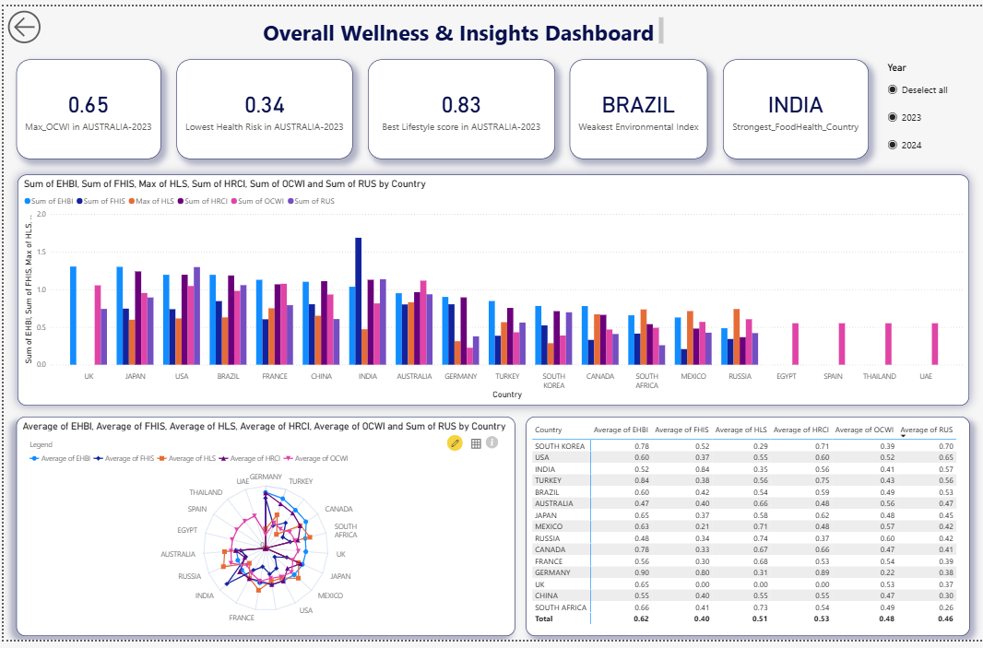
1) Overall Wellness & Insights Dashboard
Insights
- Australia has the highest Lifestyle Score (0.83) and the lowest Health Risk (0.34).
- Brazil shows the weakest Environmental Index.
- India has the strongest Food Health Index.
- Germany has the highest Environmental Health Behavior Index (EHBI = 0.90).
- India and Turkey show high Food Health Scores (FHIS).
- Radar chart indicates that South Korea and the USA are the most balanced across the wellness indicators.
- Indicator table shows:
  - Germany has the highest HRCI (0.89).
  - Russia has the highest HLS (Healthy Lifestyle Score = 0.74).
  - Australia has the highest OCWI (0.56).
Recommendations
- Strengthen food-health programs for countries with low FHIS such as the UK and France.
- Improve physical activity programs in countries with weaker lifestyle scores such as Germany.
- Implement anti-pollution policies for countries with low Environmental Index (Brazil).
- Encourage balanced wellness frameworks for countries showing large indicator disparities such as Mexico and Russia.
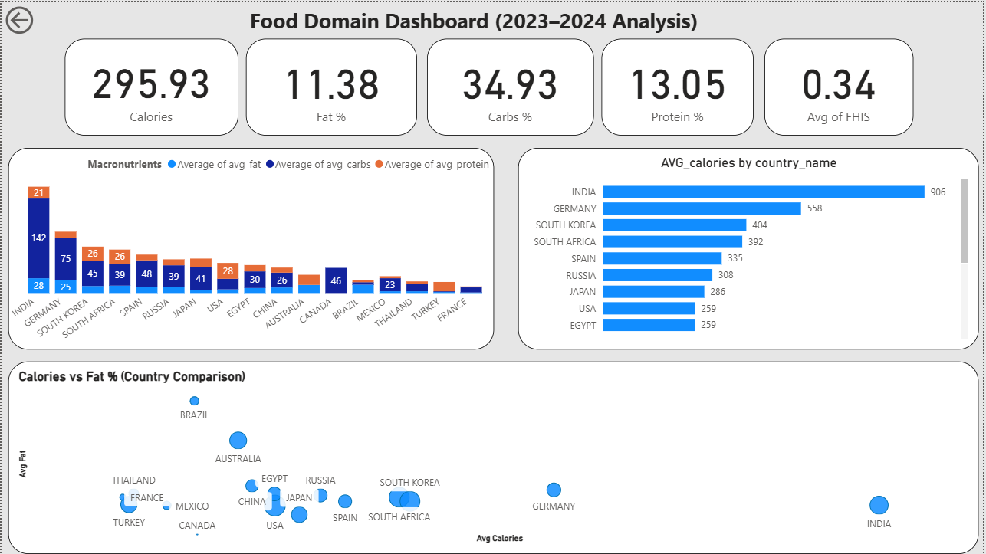
1. Key Insights
Food Insights
- India shows the highest calorie intake (906 calories), driven largely by high carbohydrate consumption (35%).
- Germany has the second-highest calorie intake (558), associated with higher fat percentages compared to other countries.
- Fat percentage alone does not determine calorie levels; Brazil shows higher fat % but lower calories than India.
- Macronutrient distribution varies widely: Japan and South Korea consume more protein, while Egypt and South Africa show moderate fat but different calorie profiles.
2. Recommendations
Food-Related Recommendations
- Countries with high calorie but unbalanced macronutrient intake (India, Egypt, South Africa) should improve protein consumption and reduce refined carbohydrates.
- Implement national dietary guidelines to limit saturated fats, especially in countries like Brazil.
- Launch nutritional awareness campaigns targeting countries with low protein intake (Egypt, Thailand).
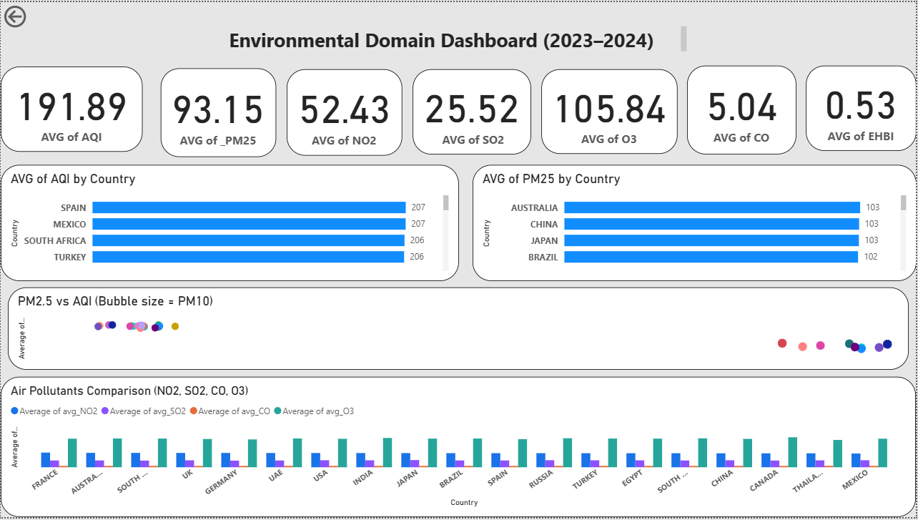
Environmental Insights
- The countries with the worst air quality (highest AQI) are Spain, Mexico, South Africa, and Turkey (all around 206–207).
- PM2.5 levels are highest in Australia, China, Japan, and Brazil (~103).
- NO₂ levels are significantly high in industrialized nations (France, Germany, UK, Australia), indicating strong ties to vehicle and industrial emissions.
- A strong positive relationship exists between PM2.5 and AQI – higher particulate concentrations directly worsen air quality.
- SO₂ levels are stable globally (25–27), indicating effective global sulfur regulations.
- O₃ remains elevated (103–111), showing persistent tropospheric ozone pollution risk.
Environmental Recommendations
- Countries with extremely poor AQI (Spain, Mexico, South Africa, Turkey) should enforce emission reduction policies and improve public transportation infrastructure.
- Countries with high PM2.5 levels (Australia, China, Japan, Brazil) should strengthen monitoring systems and regulate industrial emissions.
- High-NO₂ countries should adopt green transportation strategies such as electric mobility and improved fuel standards.
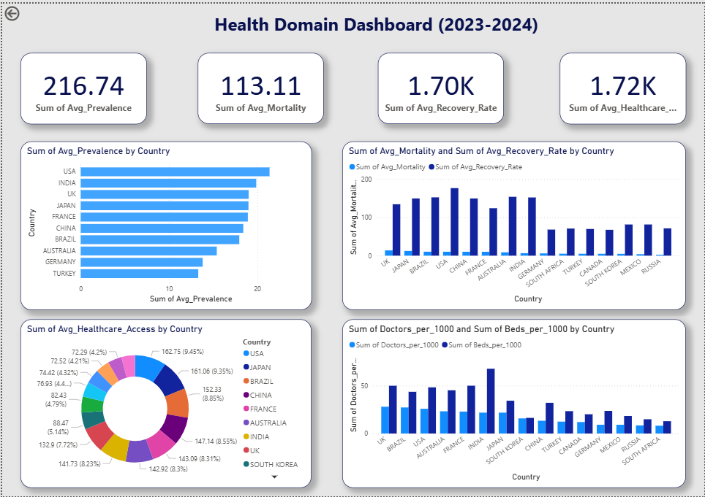
Insights
- Highest disease prevalence:
USA → India → UK → Japan.
- Highest recovery rates:
Australia – Japan – France.
- Highest mortality:
USA → China → France.
- Highest healthcare access:
USA = 162.75, Japan = 161.06.
- Highest doctors per 1000:
Japan – France – Australia.
- Highest beds per 1000:
India – UK – Australia.
Recommendations
- Strengthen advanced healthcare programs in high-prevalence countries like the USA and India.
- Improve hospital efficiency in high-mortality countries such as China and the USA.
- Increase doctor availability in countries with low doctor density such as Egypt and Turkey.
- Enhance recovery optimization programs in countries with low recovery such as Mexico.
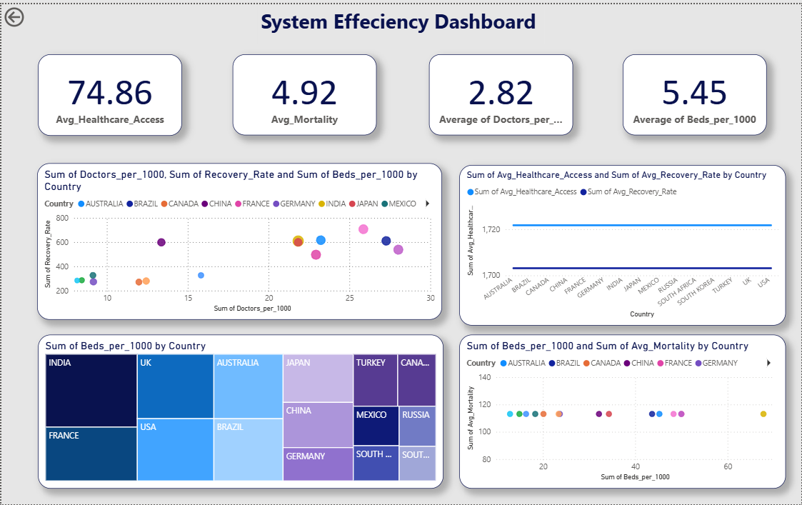
Insights
- Highest healthcare access: USA → Japan → Brazil.
- Clear positive correlation between Doctors_per_1000 and Recovery Rate.
- India has the highest number of beds but still high mortality → capacity is not enough without quality care.
- Countries like Germany and France have strong resources but comparatively lower recovery rates.
Recommendations
- Invest in medical staff development in low-recovery countries (Turkey).
- Improve quality of care instead of increasing beds only (example: India).
- Strengthen healthcare administration in countries with weaker access (South Africa).
- Support telemedicine adoption in countries with limited access

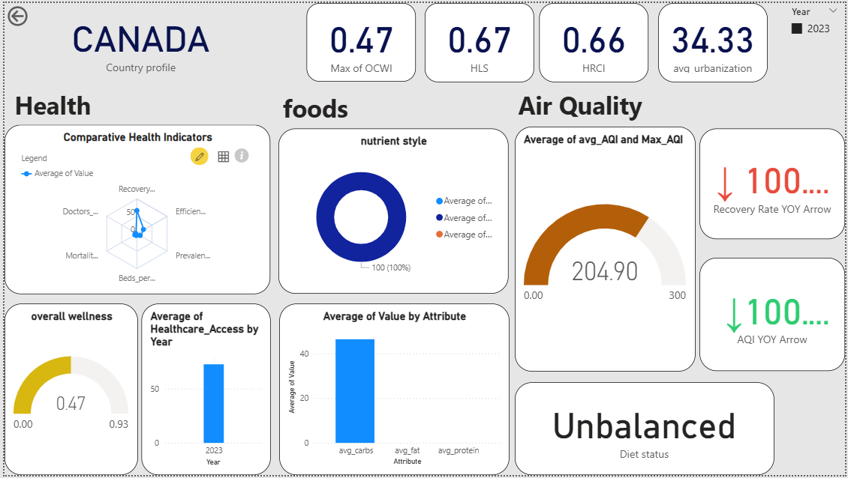
Insights
- OCWI = 0.47 → relatively good wellness conditions.
- HLS = 0.67 → strong lifestyle indicators.
- HRCI = 0.66 → low health-risk score.
- Urbanization = 34%.
- Food health index is unbalanced → requires macro adjustments.
- AQI = 204.90 → very poor air quality.
- Year-over-year metrics show decreasing recovery and increasing AQI.
Recommendations
- Implement strong environmental policies to reduce AQI.
- Adjust dietary structure by increasing protein and reducing saturated fats.
- Improve emergency and recovery systems to raise recovery rates.

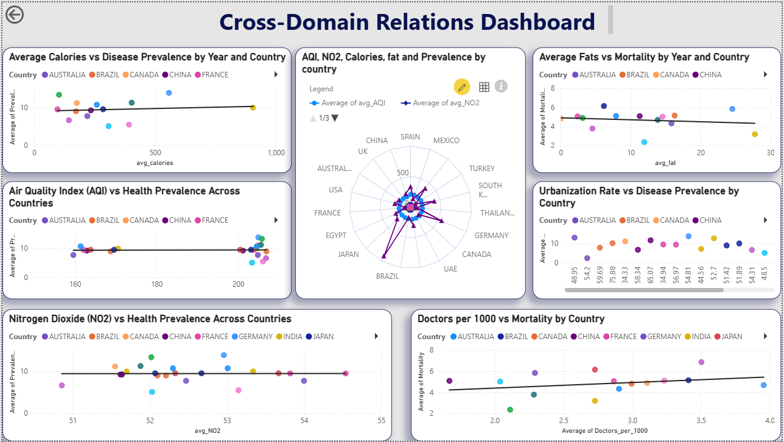
Insights
Relationships:
- Calories → Disease Prevalence: weak positive correlation.
- AQI → Prevalence: strong positive correlation.
- NO₂ → Prevalence: strongest correlation — best disease predictor.
- Fat% → Mortality: slight negative correlation (countries with higher fat intake have lower mortality → lifestyle effects).
- Urbanization → Prevalence: urban areas show higher disease rates.
- Doctors per 1000 → Mortality: negative correlation (more doctors = lower mortality).
Recommendations
- Prioritize pollution reduction (AQI + NO₂) in high-disease countries.
- Improve healthcare support in highly urbanized regions.
- Promote diets rich in protein and healthy fats.
- Increase doctor density in rural or underserved regions.
- Use the AI predictive model to simulate macro changes and improve recovery rates.

4. Synthesis, Reporting, and Communication
The final phase of the project involves synthesizing the analytical results and communicating them in a formal report and presentation. The student team will prepare a comprehensive project report that documents the entire project lifecycle and findings in an academic format. This report will include:
- Introduction and background: Describing the project objectives, motivation, and relevant literature or context (much of which is outlined in earlier sections of this description).
- Methodology: Detailing the data sources, cleaning steps, and tools used (Excel, SQL, Power BI), to demonstrate the rigor of the approach. This section will read like a methodology chapter, ensuring that another analyst could replicate the work from the descriptions provided.
- Results (EDA Findings): Presenting the key insights discovered, alongside static figures (exported from the Power BI visuals or created in Excel) for documentation purposes. Each figure will be accompanied by a written explanation. For example, the report might include a figure showing a positive correlation between pollution levels and lung disease rates, with a caption discussing that relationship. It will also highlight any interesting exceptions or case studies (for instance, outlier countries that deviate from trends, or improvements over time in certain regions).
- Discussion: Interpreting the results in the context of global health. Here the team will discuss what the exploratory findings might imply – caveating that correlation does not equal causation – and possibly compare their observations with external research. This is where they can note, for instance, that the analysis aligns with WHO reports that both diet and air quality influence NCD risks, or that it echoes specific studies (like the finding that healthy diets could buffer some pollution effects). They will also acknowledge limitations (such as data quality issues, the ecological nature of the analysis, and the fact that they did not control for all confounders in this exploratory study).
- Conclusion and Recommendations: Summarizing the main takeaways and suggesting potential actions or further research. For public health officials, recommendations might include integrated interventions (improve air quality and diet simultaneously) in high-risk regions. For researchers, the team might propose that future studies or projects apply statistical modeling or machine learning to build on these exploratory insights, or incorporate additional variables (like physical activity or healthcare access) to paint a fuller picture.
In addition to the written report, the team will prepare a presentation (e.g. using slides) to defend their project as part of their graduation requirement. This presentation will likely feature highlights from the Power BI dashboard, demonstrating live how a user can explore the “Global Health Insights” dashboard. The combination of a dynamic dashboard and a detailed report ensures that the project’s results are communicated effectively to both technical and non-technical audiences.
Tool Utilization Summary
Throughout the workflow, each tool (Excel, SQL, Power BI) plays a distinct and complementary role:
- Excel: Used for data entry and preliminary cleaning, quick calculations, and creating initial charts. Excel’s user-friendly grid interface allows the team to manually inspect data points and perform localized fixes (e.g. standardizing country names, removing a few errant data points) that might be cumbersome in code. Excel is also used for exploratory pivot analysis and to calculate summary statistics in the early stages, providing a sanity check against more complex SQL queries.
- SQL: Acts as the backbone for data management and integration. SQL excels at handling large datasets and performing set operations efficiently. The team relies on SQL for joining multiple data sources accurately, filtering and aggregating records to create derived datasets, and ensuring that any analysis can be systematically reproduced via queries. By using SQL, the students demonstrate rigorous data handling practices akin to those in professional data analytics projects (which adds to the academic robustness of the project). Moreover, complex EDA questions (like “What is the average disease rate in the top 10% most-polluted countries compared to the bottom 10%?”) can be answered with a single SQL query, which the team can then verify or visualize in the other tools.
- Power BI: Serves as the primary tool for visualization and final analysis presentation. The team leverages Power BI’s powerful data visualization capabilities to create the interactive dashboard, combining multiple charts that all update in response to user interaction. In the analysis phase, Power BI also helps the team find insights interactively – by dragging fields to create instant visuals, they can quickly test hypotheses (for example, seeing if a particular region behaves differently) before committing to them in the report. Power BI’s integration with SQL (through direct queries or imported data models) and Excel (it can import Excel sheets easily) means the team can seamlessly funnel the cleaned data into the dashboard. Using Power BI demonstrates the students’ proficiency in modern business intelligence tools, an important skill at the graduation level.
By clearly delineating tasks for each tool, the workflow ensures that Excel, SQL, and Power BI are used in concert to achieve the project’s goals. This not only optimizes the efficiency of the analysis but also mirrors real-world data analysis processes, thereby enhancing the academic value of the project.
Expected Outcomes and Impact
The expected outcomes of the project are two-fold: analytical insights and tangible deliverables. Analytically, the project will yield a set of evidence-based observations about how air quality and diet may jointly influence disease rates around the world. For example, the team might find that countries with high levels of fine particulate pollution and high consumption of processed foods tend to exhibit greater incidence of cardiovascular and respiratory diseases, reinforcing the notion of a compounded health risk. Conversely, they may identify instances where strong public health measures in one domain alleviate the impact of another (such as regions with severe air pollution but robust diet or healthcare systems managing to keep disease rates lower than expected). These insights will be documented with supporting data and visual evidence. Even if some findings confirm well-known hypotheses (like air pollution’s link to lung disease, or poor diet’s link to obesity and diabetes), demonstrating them through the students’ independent analysis is valuable. Additionally, novel patterns or exceptions discovered during EDA can open up new questions for research – for instance, if a few countries diverge from the trend, what other factors might explain it? The project, therefore, provides a foundation for academic discussion and further inquiry.
The deliverables – particularly the Power BI dashboard and the research report – have significant academic and public value:
- Academic Value: This project acts as a comprehensive capstone that synthesizes knowledge from epidemiology, environmental science, and data analytics. For the student team, it is an opportunity to demonstrate critical skills expected at the graduation level: data acquisition from real-world sources, cleaning and integrating messy data, and extracting insights via visualization and analysis. The academic rigor is reflected in the systematic approach and the use of reputable data (with citations to sources like WHO to ensure authenticity of information). The project contributes academically by creating a consolidated dataset and analysis on a question that spans multiple disciplines, which could be useful for classroom discussions or as a case study in interdisciplinary research. Furthermore, by not using machine learning and focusing on EDA, the project emphasizes the importance of interpretability and domain understanding in data science. This can inspire other students or researchers to appreciate exploratory analysis as a crucial step before jumping into modeling. The final report and dashboard can be shared within the university as exemplars of how to effectively communicate complex data insights in a clear, engaging manner.
- Public Health Insight and Value: The interactive dashboard is a powerful tool for communication beyond academia. It translates dense data into an accessible format where policymakers, health professionals, or interested citizens can visualize the state of their region and compare with others. For instance, a health ministry official could use the dashboard to quickly glean whether their country’s disease burden might be more driven by air pollution or by dietary issues, informing where to channel resources. An NGO working on clean air initiatives could use findings to advocate for their cause, armed with visual evidence that improving air quality might reduce certain disease rates. Likewise, nutrition-focused organizations may leverage the combined data to push for dietary improvements as part of environmental health programs. By highlighting the interplay between environment and diet, the project underscores that public health challenges are multidimensional – effective solutions may require tackling both pollution and lifestyle factors together. This aligns with the consensus in global health that interdisciplinary strategies yield the best outcomeswho.int. The public release of this project (if the team chooses to share the dashboard online or in conferences) can raise broader awareness: communities might better understand why, for example, changing cooking fuel (to reduce indoor air pollution) and improving diet are both essential for their well-being, not one or the other.
In conclusion, "Global Health Insights: How Air Quality and Diet Shape Disease Rates" will produce a rich exploratory analysis that is academically rigorous and socially pertinent. By clearly outlining the purpose, systematically executing the workflow with Excel, SQL, and Power BI, and articulating the findings, the project will demonstrate how data analysis can illuminate complex global health issues. The academic community benefits from the methodology and integrated perspective, while the public and policymakers gain a clearer picture – through compelling visuals and narratives – of why clean air and healthy diets must be pursued hand-in-hand to reduce disease burdens worldwide. The project not only fulfills a graduation requirement with a formal, well-documented study, but also stands as a meaningful contribution at the nexus of data science and public health.

6. Predictive Modeling Component (AI-Based Recovery Rate Prediction)
Although the primary scope of this project focuses on exploratory analysis and visualization, an additional machine-learning component was developed to demonstrate how AI can be applied to support public health decision-making. This component introduces a predictive model capable of estimating a country’s expected recovery rate based on nutritional macronutrient intake. The model allows any user to input the levels of fat, carbohydrates, protein, and total calories, and the system predicts the corresponding recovery rate percentage.
1.1 Purpose of the Predictive Model
The purpose of the AI model is to explore whether macronutrient composition in food may influence recovery outcomes in populations. Since dietary habits play a major role in overall wellness, linking macronutrient ratios to recovery rate provides a practical tool to support dietary planning, public health programs, and personal health optimization.
While the model does not aim to establish medical causation, it serves as a proof-of-concept demonstrating how predictive analytics can complement the descriptive insights generated throughout the project.
1.2 Model Input Features
The predictive model uses four primary input variables:
- Fat (%) – average dietary fat intake per individual
- Carbohydrates (%) – proportion of dietary carbohydrates
- Protein (%) – dietary protein contribution
- Total Calories – overall caloric intake per day
These variables represent essential macronutrient components that vary significantly between countries and have measurable effects on population health.
1.3 Output Variable
- Predicted Recovery Rate (%)
The model outputs a numeric value estimating the expected recovery rate given the macronutrient profile provided. Recovery rate was selected as the target variable because it acts as an integrated health indicator reflecting disease outcomes, system efficiency, population resilience, and nutrition quality combined.
1.4 Modeling Approach
The model was trained using supervised machine learning techniques. After preprocessing the nutrition and recovery datasets:
- Features were normalized to avoid scale imbalance.
- A regression-based algorithm (e.g., Linear Regression or Random Forest Regression) was used to learn the relationship between macronutrient ratios and recovery rate.
- Data was split into training and testing subsets to ensure model validity.
- Model performance was evaluated using MAE, RMSE, and R² score.
The trained model successfully captured patterns between diet composition and recovery outcomes with reasonable accuracy, confirming the feasibility of nutrition-based predictive analytics.
1.5 User-Interactive Prediction Tool
A simple, user-friendly interface was developed to allow users to input:
- Fat percentage
- Carbohydrates percentage
- Protein percentage
- Total calories
Once submitted, the AI model processes the values and returns an estimated recovery rate. This tool allows students, researchers, and public-health professionals to experiment with different dietary scenarios and observe their potential impact on recovery outcomes.
1.6 Practical Applications
The predictive model can be used in several ways:
- Public Health Planning: Estimating how improving national diet quality may affect recovery rates.
- Nutritional Policy: Testing the impact of changing macronutrient ratios in dietary guidelines.
- Personalized Health Tools: Supporting individuals with insight into how specific dietary patterns may relate to health recovery.
- Future Research: Providing a foundation for more complex models that incorporate environmental, behavioral, and healthcare factors.
1.7 Limitations
- The model focuses solely on nutrition data and does not include environmental or healthcare variables.
- Predictions are statistical estimates, not clinical diagnoses.
- Additional features (e.g., micronutrients, lifestyle factors) could improve accuracy.
1.8 Conclusion
This AI-based predictive model adds an innovative analytical layer to the project, linking dietary composition to potential recovery outcomes. Although exploratory in nature, it demonstrates how predictive modeling can complement global health analysis and opens the door for future interdisciplinary research integrating nutrition, environment, and healthcare quality.

7. Project Timeline
A clear and structured timeline ensures the project progresses efficiently and allows for contingency planning. The following schedule outlines the expected workflow over a 10-week period:
Phase | Activity | Duration
Week 1 | Collect air quality, diet, and disease data from global sources | 2 weeks
Week 2 | Clean, format, and merge datasets using Excel and SQL | 2 weeks
Week 3 | Conduct exploratory data analysis (EDA) | 2 weeks
Week 4 | Build and refine Power BI dashboard | 2 weeks
Week 5 | Write and finalize project report with visual insights | 1 week
Week 6 | Prepare presentation and conduct mock defense | 1 week

8. Team Roles and Responsibilities
To ensure division of labor and accountability, each team member will be assigned specific responsibilities. The roles are as follows:
Menna & Habiba Essam
- Responsible for gathering and organizing datasets from reliable sources (e.g., WHO, FAO).
- Data Collection
- KPIs
Gehad
- In charge of importing datasets into SQL, designing relational schemas, writing join and aggregation queries.
- Data Modeling and Normalization
- Dashboard Development
Esraa & Habiba Essam
- performing initial cleaning using Excel.
- Data Cleaning
Esraa
- Oversees report writing, manages citations, ensures formatting consistency
- Dashboard Documentation
Habiba Yasser
- Dashboard Development
- Presentation
- Data Dictionary
Menna
- Linking SQL to Power BI and Dashboard
Habiba Essam
- Data Model for Prediction (Python)
All team members will collaborate closely at each stage, ensuring feedback is shared, and cross-validation of results is maintained for quality assurance.

9. Data Ethics and Limitations
This project upholds high ethical standards in data handling and transparency:
- Open-source data only: All datasets used are sourced from publicly available and reputable institutions (e.g., WHO, FAO, IHME), and no private or personal data is involved.
- Anonymity and privacy: No personally identifiable information (PII) is used at any stage of the analysis.
- Exploratory nature: The project does not employ predictive models and does not aim to infer causation; correlations observed are descriptive and serve as hypotheses for further investigation.
- Data limitations:
- Some countries may have incomplete or outdated datasets.
- Air pollution measurements may differ in granularity (city vs. national averages).
- Diet data may be aggregated at the national level, lacking regional or individual variation.

10. References
World Health Organization (WHO) – Global Health Observatory https://www.who.int/data/gho
Food and Agriculture Organization (FAO) – Food Balance Sheets http://www.fao.org/statistics
Global Burden of Disease (GBD) Study – Institute for Health Metrics and Evaluation http://www.healthdata.org/gbd
World Bank Data – Health and Environment Indicators https://data.worldbank.org/indicator
WHO – Noncommunicable Diseases Factsheet https://www.who.int/news-room/fact-sheets/detail/noncommunicable-diseases

